Question 0
Tao site : [1]
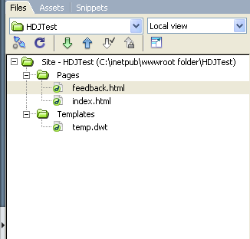
Question 1 [10]
Tao template:

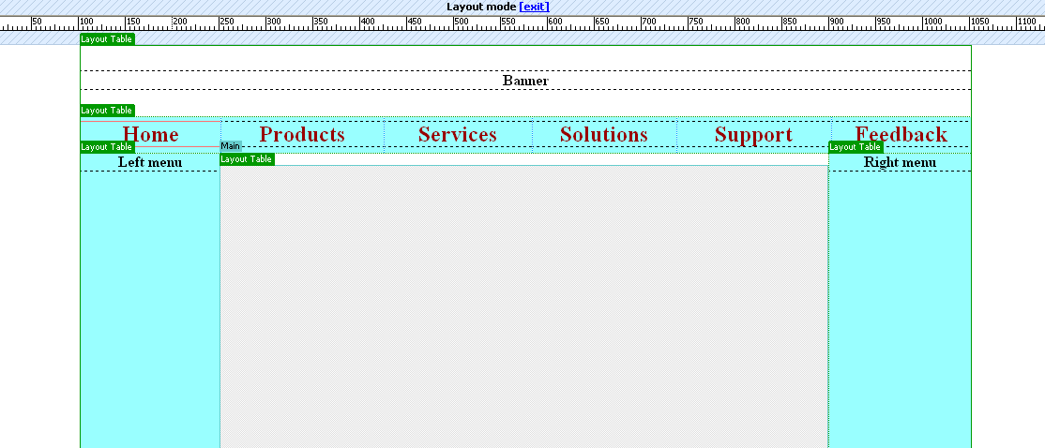
Editable region
(Main content)
Top menu
Require:
- The background color in the Top menu, left menu and right menu are “#99FFFF”, text color in the Top menu are “#990000”

- When user move mouse over the text in the Top menu, the text color change to “#FFFF00”, and when user move out the text color come back to “#99FFFF”.

- “Home” and “Feedback” in the Top menu are hyperlinks (is never underline). “Home” link to “index.html” (Question 2), “feedback” link to “feedback.html” (Question 3).

Question 2: [1]
Using template is created in question 1 to create “index.html” or “index.htm” page.
You must sure that, when user click on “Feedback” in the Top menu, the feedback.html (or feedback.htm) is opened (“Feedback” menu must link to feedback.html or feedback.htm page - descript in the Question 3).

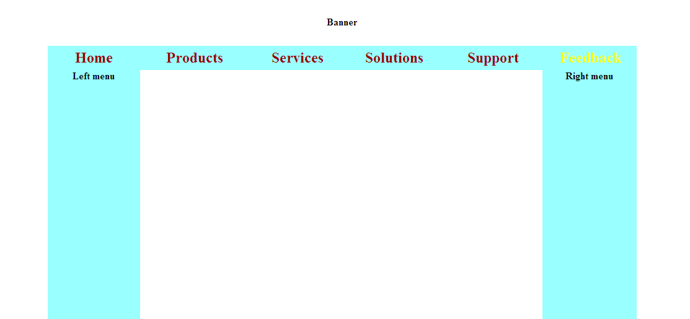
Question 3: [13]
Using template is created in question 1 to create feedback.html (or feedback.htm) as below: [5]

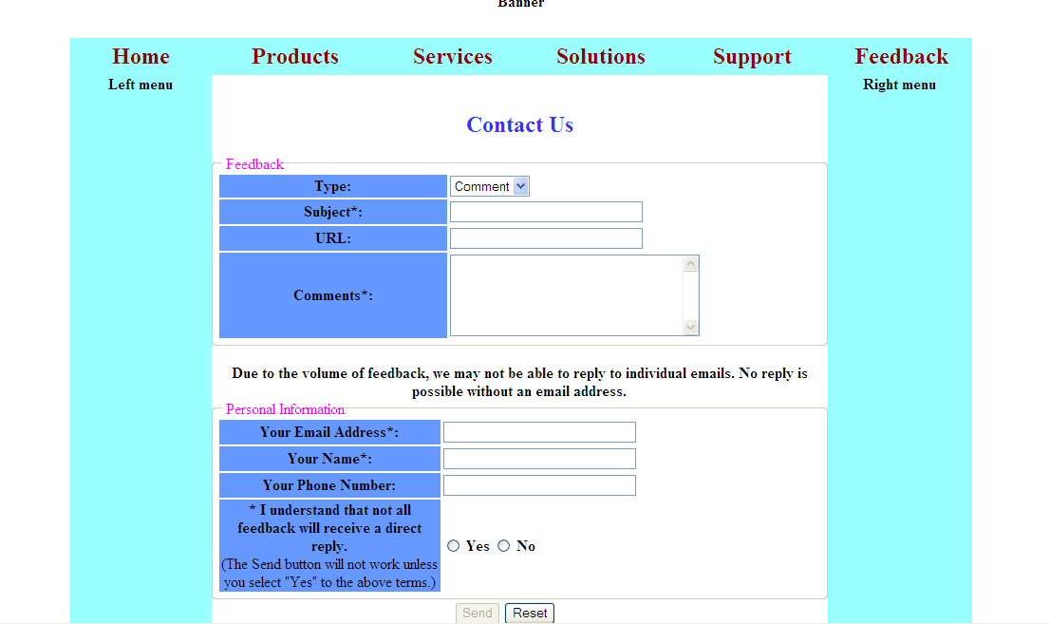

Content:
- “Contact Us” is “#3333FF” color
- The legend of field sets “Feedback” and “Personal Information” are “#FF00FF” color
- The “Send” button is disabled
- Background of left column is “#6699FF”
- Type:
+ Comment
+ Requirement
Require
- When user Click on Reset Button, all field must be cleared. [0.5]
- When radio button “Yes” is choose, button “Send” is available. When radio button “No” is choose, button “Send” is disabled. [2]
- When user Click on “Send” Button, following validations will be performed: [5]
- All fields that have “*” in the label are required (not empty). If one of them is empty, Message Box will display
- Email: Input as formal username@domainName
- Name: The name field includes only characters (a-z or A-Z) or spaces.
- Phone: Input only numerals (0-9)

- If no error, show message “Thanks for your comment! We will reply your comment as soon as possible!” [0.5]

